

**END OF TERM ONE EXAMINATIONS 2023**

**TOP CLASS**

**LANGUAGE DEVELOPMENT ONE**

NAME_________________________________________

# Write the letters a – z.

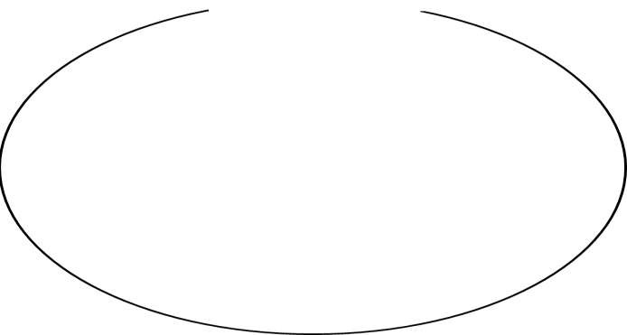

a , , ,

, , ,

, , , , ,

, , , , ,

, , , , , z

1. **Name the pictures.**

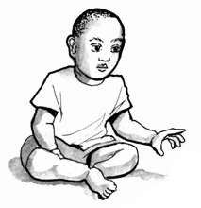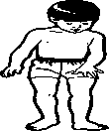

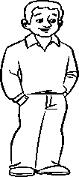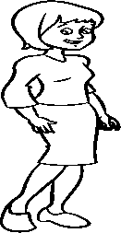

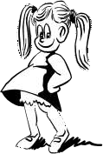

(sister , baby , father , brother , mother)

# Write the picture number.

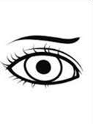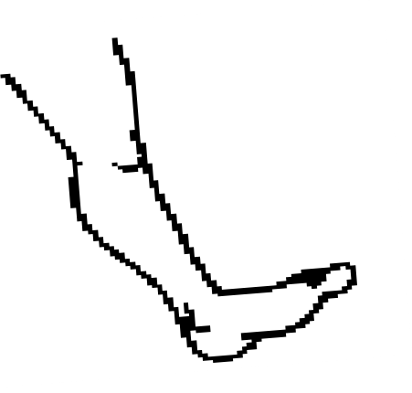

**6**

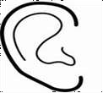

**1**

**4**

**3**

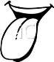

**2**

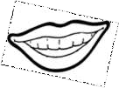

**5**

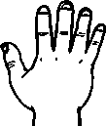

**7**

|  |  |
| --- | --- |
| leg |  |
| eye |  |
| nose |  |
| ear |  |
| mouth |  |
| fingers |  |
| tongue |  |

# Circle the right word for picture.

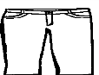 dress

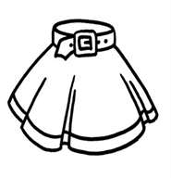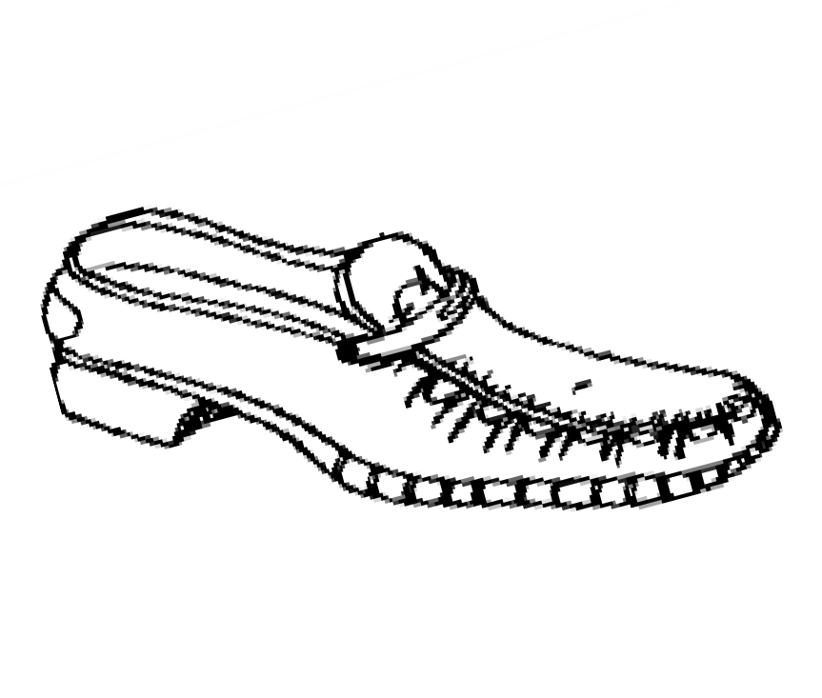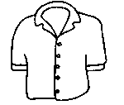

short

skirt shirt

shoe shirt

shirt sun

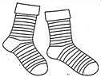shoes stockings

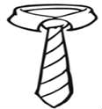tie tin

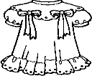trousers dress

# Fill in the missing letters.

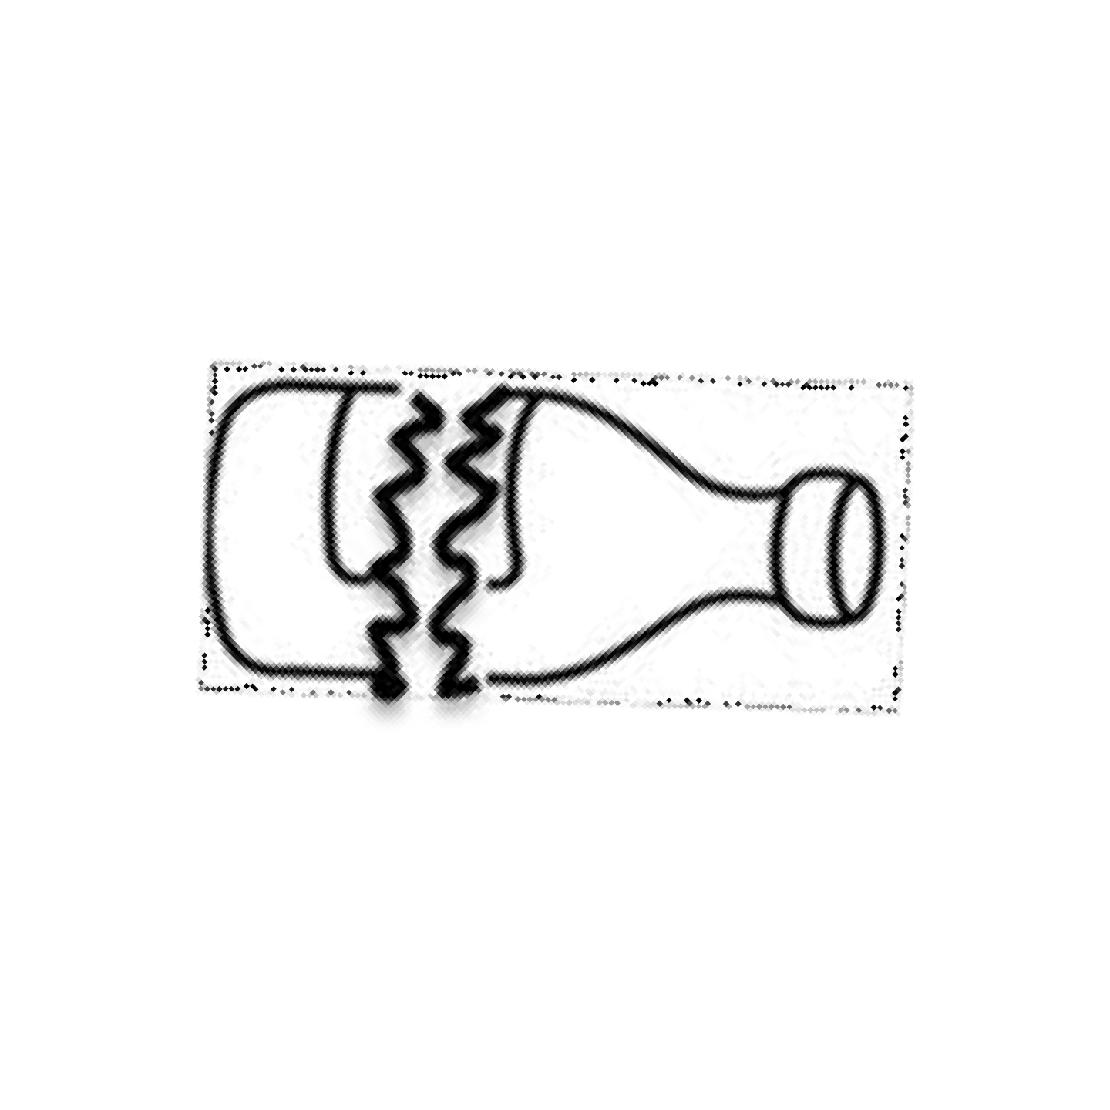

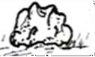n a i l s t o n e

a i l s t n

n o e

i r e

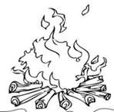

f

r e

b r o k e n b o t t l e

b k e n b o t t l e

f e

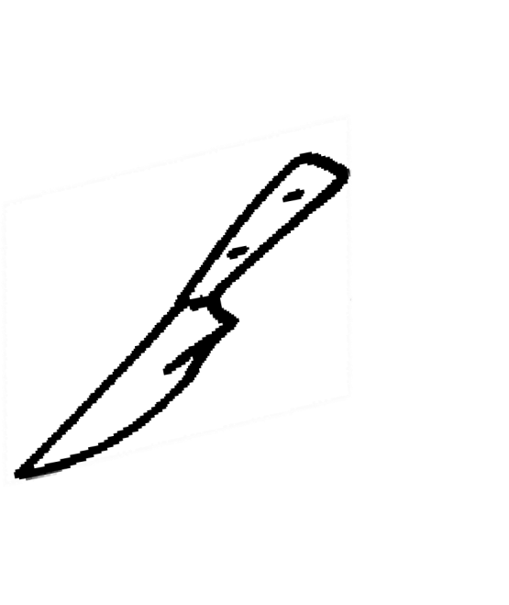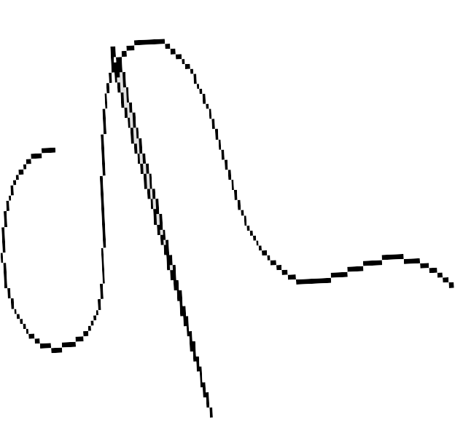n e e d l e

k n i f e n d l e

k f e

n e n e e d

**ORALS**

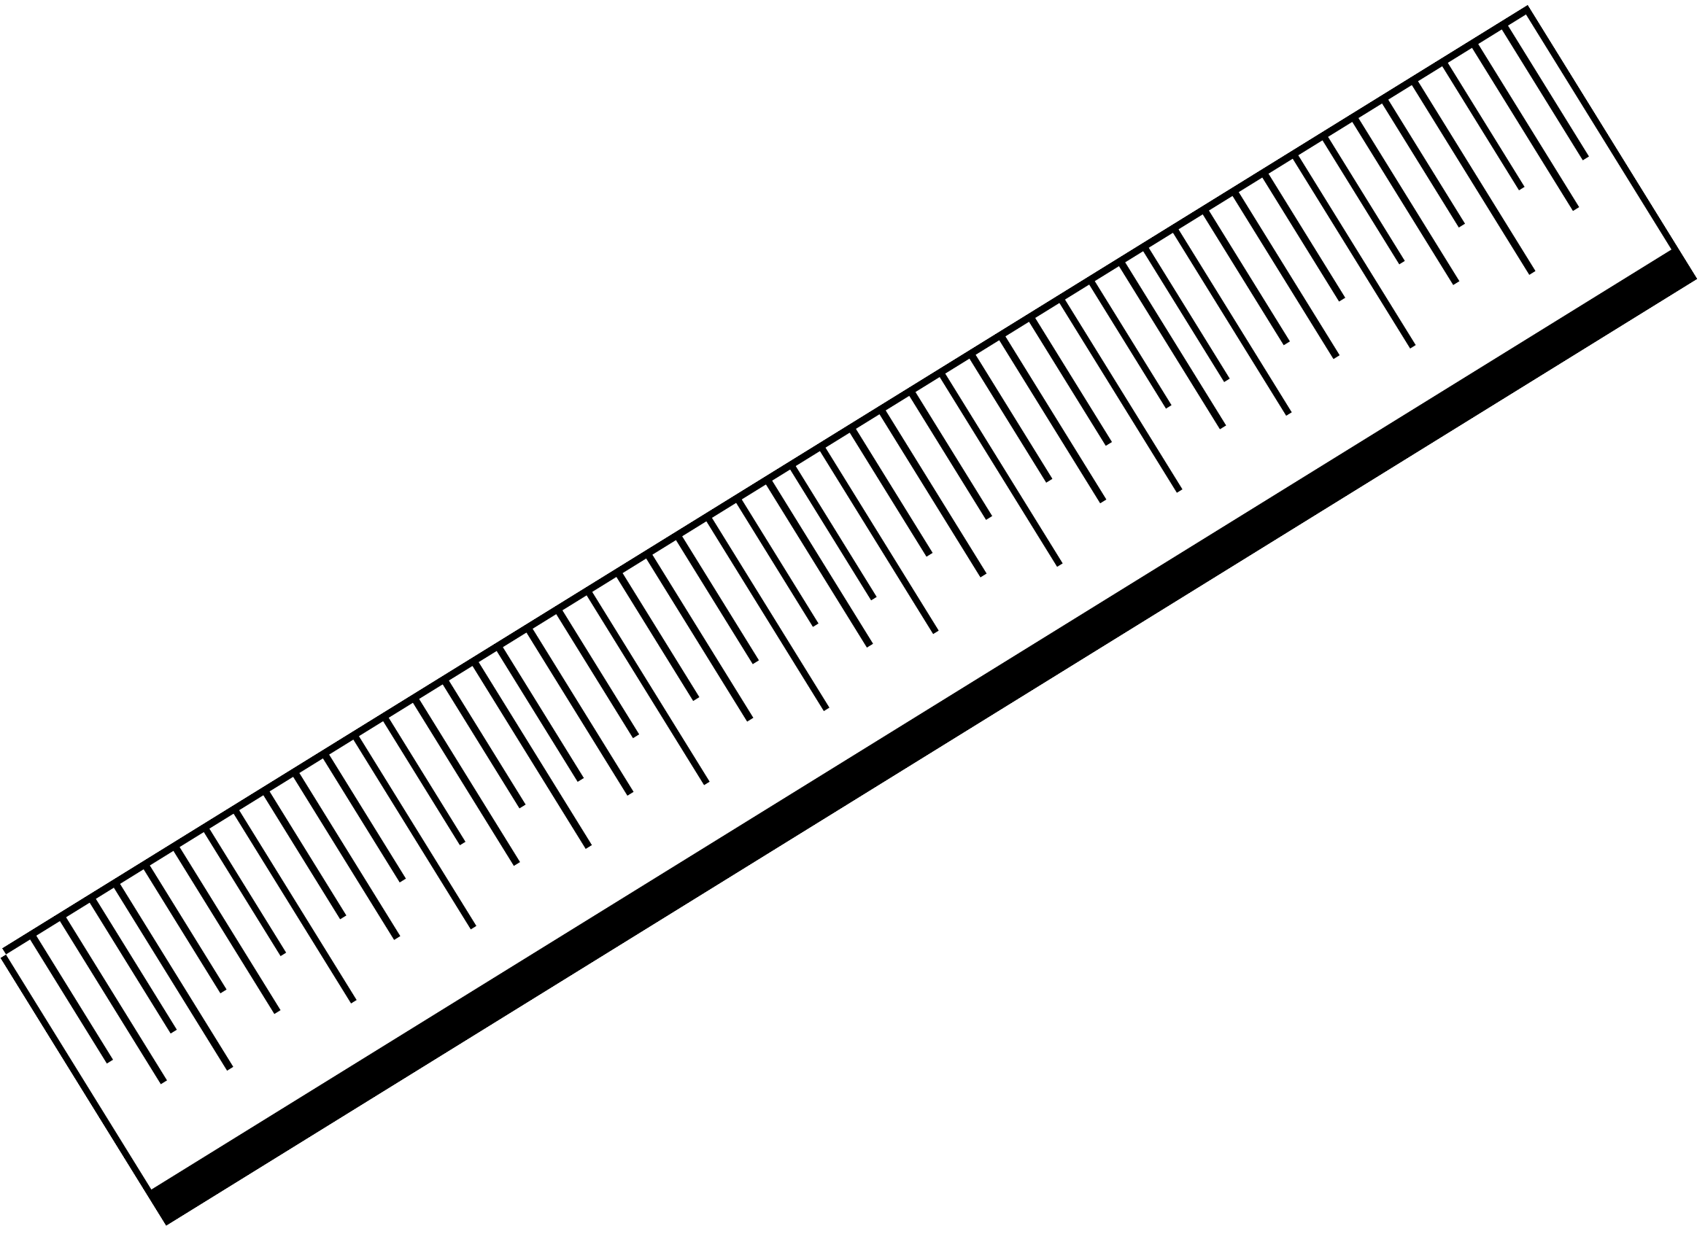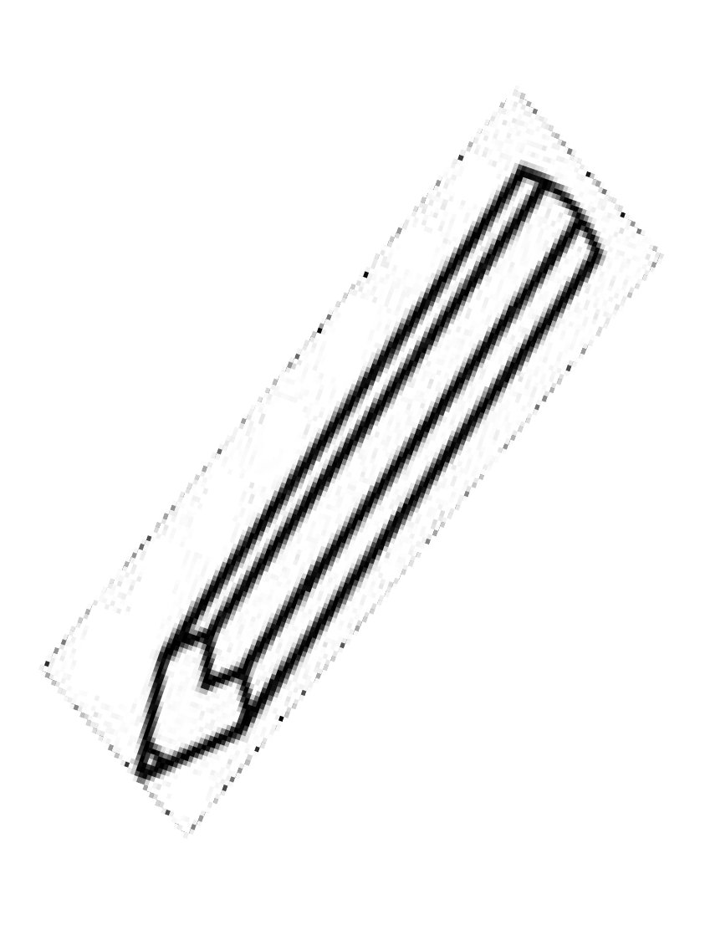

1. **Name these things found in class.**

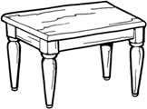

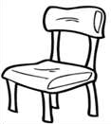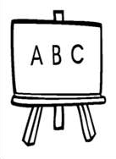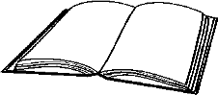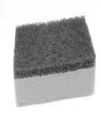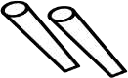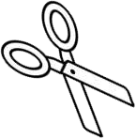

1. Who heads a family?
2. Mention the five senses.
3. In which class are you?
4. Show me your knee?

# -Good luck-